**Modeling-bus-suspension in Matlab and Simulink**

Name: Gui Yuxin

Student number: 103044

# 1. Introduction

An automatic bus suspension system is a typical control problem in the automobile industry. A widely used model for this dimensional spring-damper system is a 1/4 bus model (one of the four wheels), in which the bus is separated into two parts. A diagram of this system is shown below.

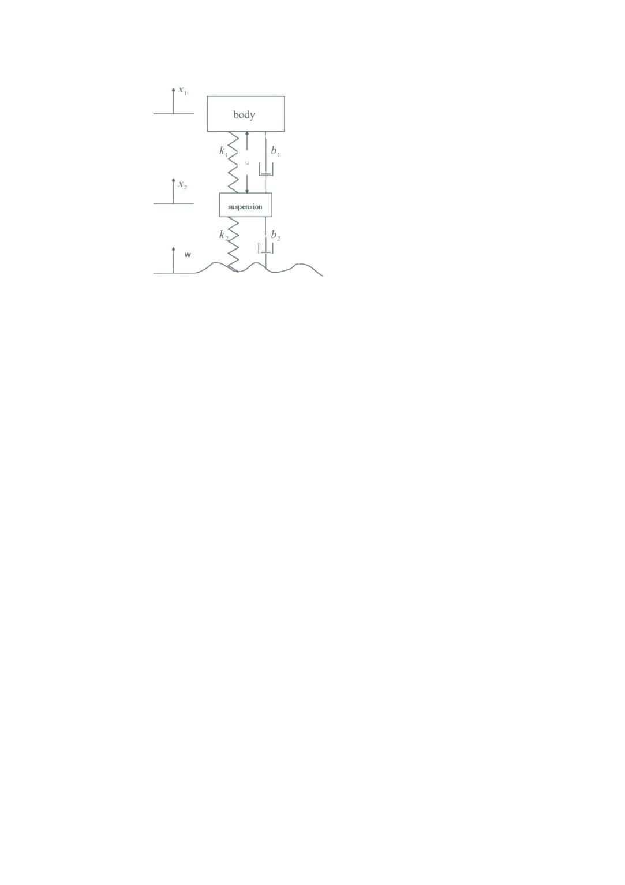

Fig.1 physical model

A qualified bus suspension system should meet two requirements. On one hand, it should have excellent road holding ability; on the other hand, it should reduce the vibration when moving over bumps and holes in the road. That is to say, the body of the vehicle should not have large oscillations, and the oscillations should dissipate as quickly as possible.

In this article, the bus suspension system is modeled with three approaches: differential equation, transfer function, and state space. After the determination of parameters, the numerical solution is calculated on MATLAB/Simulink. Then, a feedback controller is added to ensure an overshoot less than 5% and a settling time shorter than 5 seconds.

# 2. Assumption

* The road disturbance (W) in this problem is a step input.
* The distance X1-X2 is regarded as the output of the suspension system, since the distance X1-W is hard to measure and the deformation X2-W is negligible.
* The initial value of all variables is zero.
* The system is in the equilibrium position when.

# 3. Symbols and Definitions

|  |  |
| --- | --- |
|  | Body mass |
|  | Suspension mass |
|  | Spring constant of suspension system |
|  | Spring constant of wheel and tire |
|  | Damping constant of suspension system |
|  | Damping constant of wheel and tire |
|  | Control force |

# 4. Modeling

# 4.1 Differential Equation Approach

According to the Newton’s Law, the following differential equations can be obtained. This set of equation describes the motion of the two masses under the influence of actuated force and disturbance.

 (1)

# 4.2 Transfer Function Approach

Since all of the initial conditions are zero, the differential equations listed above can be transformed into the form of transfer function through the Laplace Transformation.

 (2)

The output  can be calculated with the following equation

 (3)

where





# 4.3 State Space Approach

The classical transfer function approach is suitable for single-input-single-output system (SISO). This suspension system, however, appears to be a multiple-input-multiple-output system (MIMO), which can be better described by the modern state space method.

In order to simplify the state space equations, the above-mentioned dynamic equations (1) can be written as follows:

 (4)

The equations above have the derivative of disturbance input. Unless we overlook , the system can hardly be described by ,,,. In order to set a more thorough model for the suspension system, we need to introduce new state parameters. The deriving equation and system are presented in the block diagram below.

(5)

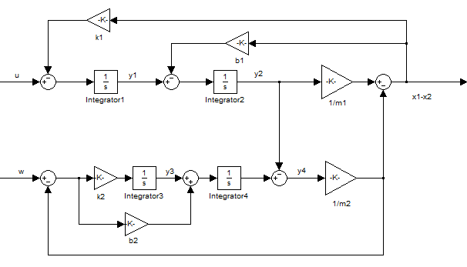

Fig.2 block diagram

According to this block diagram, this system can be described with four state variables. These four variables are the output of each integrator.

 (6)

In this case, the state equation can be presented as

 (7)

In fact, the distance  equals, and the distance  is. Hence, the outcome of this system (the distance) is. The output equation can be written as



# 5. Simulation

In order to research the response of this suspension system in a real engineering practice, the parameters in the above-mentioned models are determined with the values below.

|  |  |
| --- | --- |
|  |  |
|  |  |
|  |  |
|  |  |
|  |  |
|  |  |

# 5.1 Simulation with MATLAB

# 5.1.1 ODE approach



the equations (1) are presented as a function in a m-file with the name “suspension.m”. The codes for the function are listed below.

function dy = suspension(t,y)

u=1;w=0;wd=0;m1=2500;m2=320;k1=8e4;k2=5e5;b1=350;b2=15020;

dy=zeros(4,1);

dy=[y(3);y(4);(-k1*(y(1)-y(2))-b1*(y(3)-y(4))+u)/m1;(k2*(w-y(2))+b2*(wd-y(4))+k1*(y(1)-y(2))+b1*(y(3)-y(4))-u)/m2];

end

In this function, the initial disturbance input is zero, and the actuated force is 1N. This numerical solution is calculated by the solver ODE45 with a sentence:

>> [T,Y]=ode45('suspension',[0 10],[0 0 0 0]);

>> plot(T, Y(:,1) - Y(:,2))

Then, a diagram is plotted.

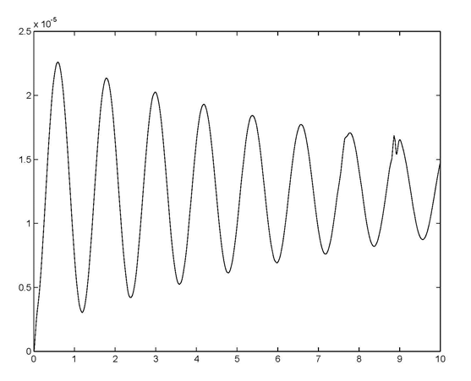

Fig.3 response to unit actuated force

Given the actuated input is zero and the disturbance input is 0.1m, the response is shown below. We only need to change u from 1 to 0 and to change w from 0 to 0.1.

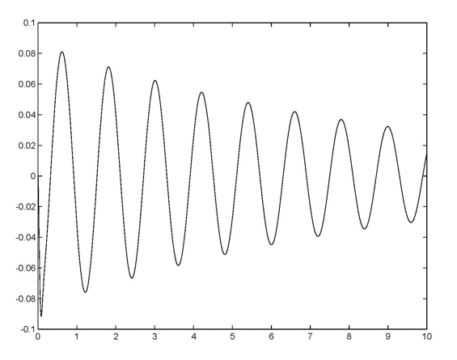

Fig.4 response to 0.1 m step disturbance

From this graph, we can see that when the bus passes a 10 cm high bump, the body will vibrate for an extremely long time with a large amplitude. Costumers in this vehicle will not feel comfortable. Therefore, a controller should be installed to minimize the vibration.

# 5.1.2 TF approach

The transfer function model can also be simulated in MATLAB with the following codes. Also, the similar graphs can be drawn.

m1=2500;m2=320;k1=8e4;k2=5e5;b1=350;b2=15020; %% set parameters

num_u=[(m1+m2) b2 k2];

den_u=[m1*m2 m1*(b1+b2)+m2*b1 m1*(k1+k2)+m2*k1+b1*b2 b1*k2+b2*k1 k1*k2];

printsys(num_u,den_u);

figure(1);

step(num_u,den_u);

num_w=[-m1*b2 -m1*k2 0 0];

den_w=[m1*m2 m1*(b1+b2)+m2*b1 m1*(k1+k2)+m2*k1+b1*b2 b1*k2+b2*k1 k1*k2];

printsys(num_w,den_w);

figure(2);

step(0.1*num_w,den_w);

# 5.1.3 SS approach

The state equations are presented as a function in a m-file with the name “suspension_ss.m”. The codes for the function are listed below. In the case, the actuated force is 0 N, and the bump is 1 m high, namely a step input.

m1=2500;m2=320;k1=8e4;k2=5e5;b1=350;b2=15020;

A=[0 -k1/m1 0 k1/m2;1 -b1/m1 0 b1/m2;0 0 0 -k2/m2;0 0 1 -b2/m2];

B=[1 0;0 0;0 k2;0 b2];

C=[0 1/m1 0 -1/m2];

D=[0 0];

sys=ss(A,B,C,D);

figure(1);

step(A,B,C,D,1);

figure(2);

step(A,B,C,D,2);

The response is shown in the graph below. Since the disturbance input is larger than the input disturbance, the response is larger than the former graph.

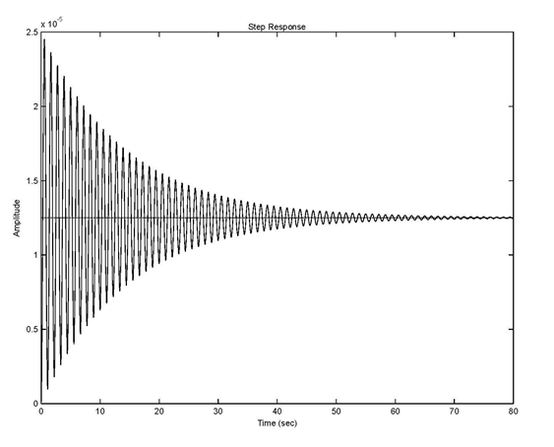

(a)

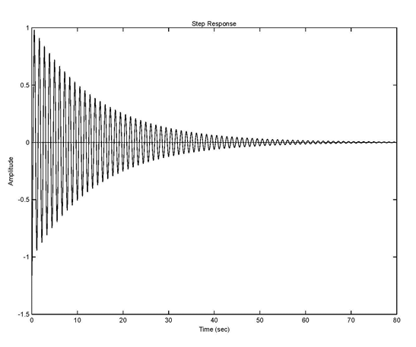(b)

Fig.5 (a) response to a unit step force (b) response to a unit step disturbance

# 5.2 Simulation with Simulink

The system can also be modeled with Simulink, which provides a direct and visual description about the system.

# 5.2.1 ODE Approach

The differential equations can be presented in the following block diagram.

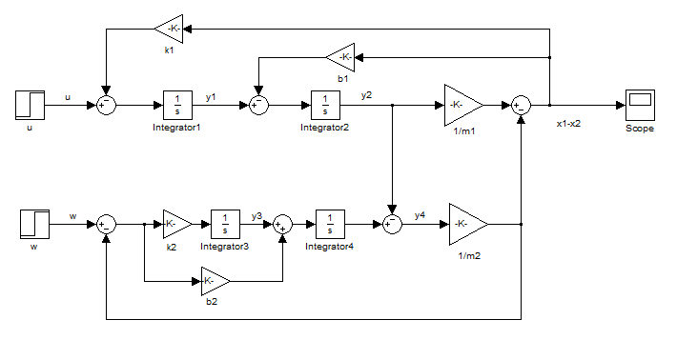

Fig.6 block diagram

From this model, we can change the input of u and w to get different output. For example, if we set u=0 and w=0.1, we will get the same result as Figure 4 from the scope.

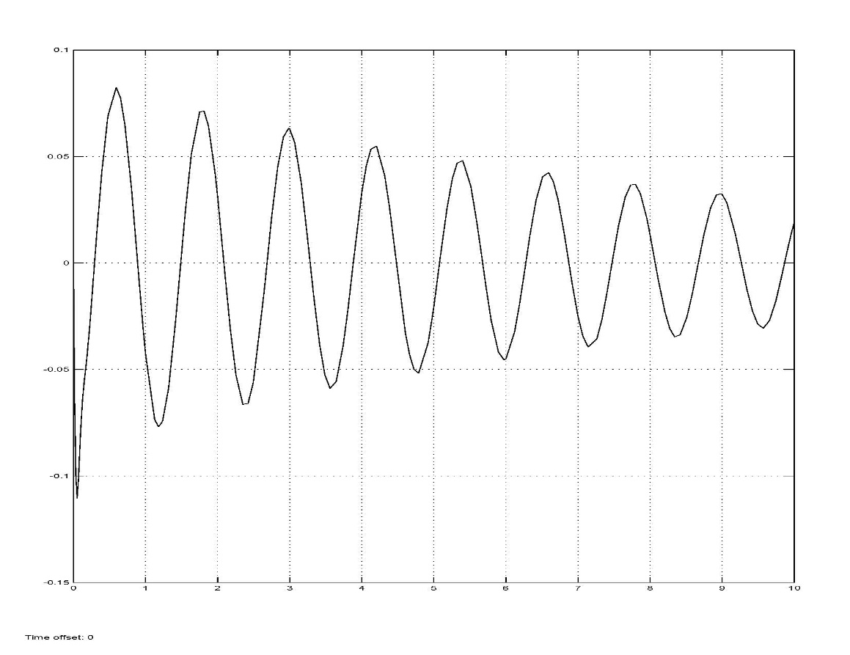

Fig. 7 response to 0.1 m disturbance

# 5.2.2 TF Approach

The transfer function approach in Simulink is presented below. In this graph, transfer function 1 has a numerator coefficient with [2820 15020 5e5] and denominator coefficient with [8e5 38537000 1480857000 1376600000 4e10]. Transfer function 2 has a numerator coefficient with [-3.755e7 -1.25e9 0 0] and denominator coefficient with [8e5 38537000 1480857000 1376600000 4e10]. These parameters are computed from the transfer function equation (3).

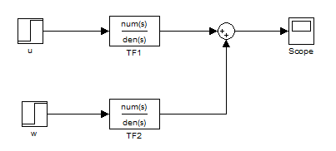

Fig. 8 block diagram

In this method, similar result is achieved.

# 5.2.3 SS Approach

According to the given parameters, we can calculate the state matrix, input matrix and output matrix. Then, we set these values into the state space block.









The simulink block diagram of state space approaches is shown as follows.

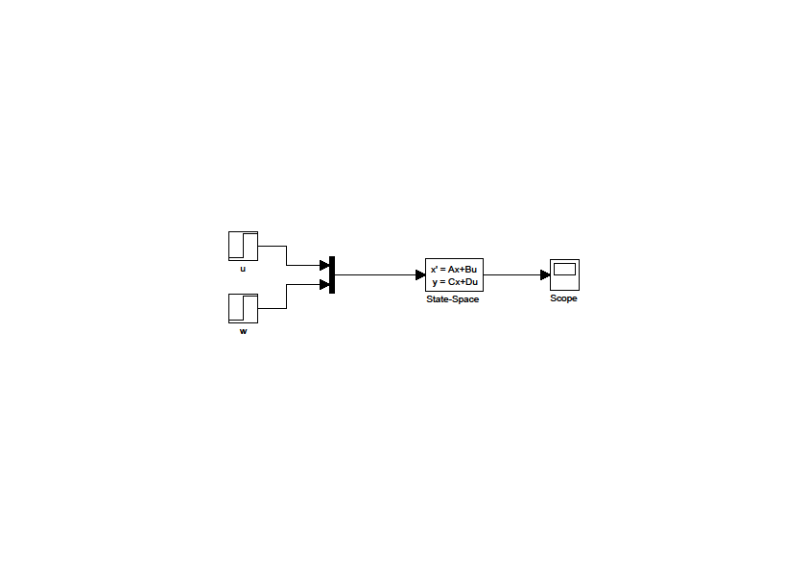Fig. 9 block diagram

# 6. PID Control

In order to meet the requirement about the suspension system’s stability on the road, a PID controller is designed with the assistance from MATLAB/Simulink. According to the transfer function model of the system, the original system with no controller is presented in the following open-loop system diagram.

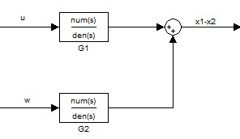

Fig.10 open-loop system with no controller





In the actual condition, however, we all want to minimize the vibration, so the target value of the system is always zero. In this case, we can simplify this diagram into this form (Fig.11).

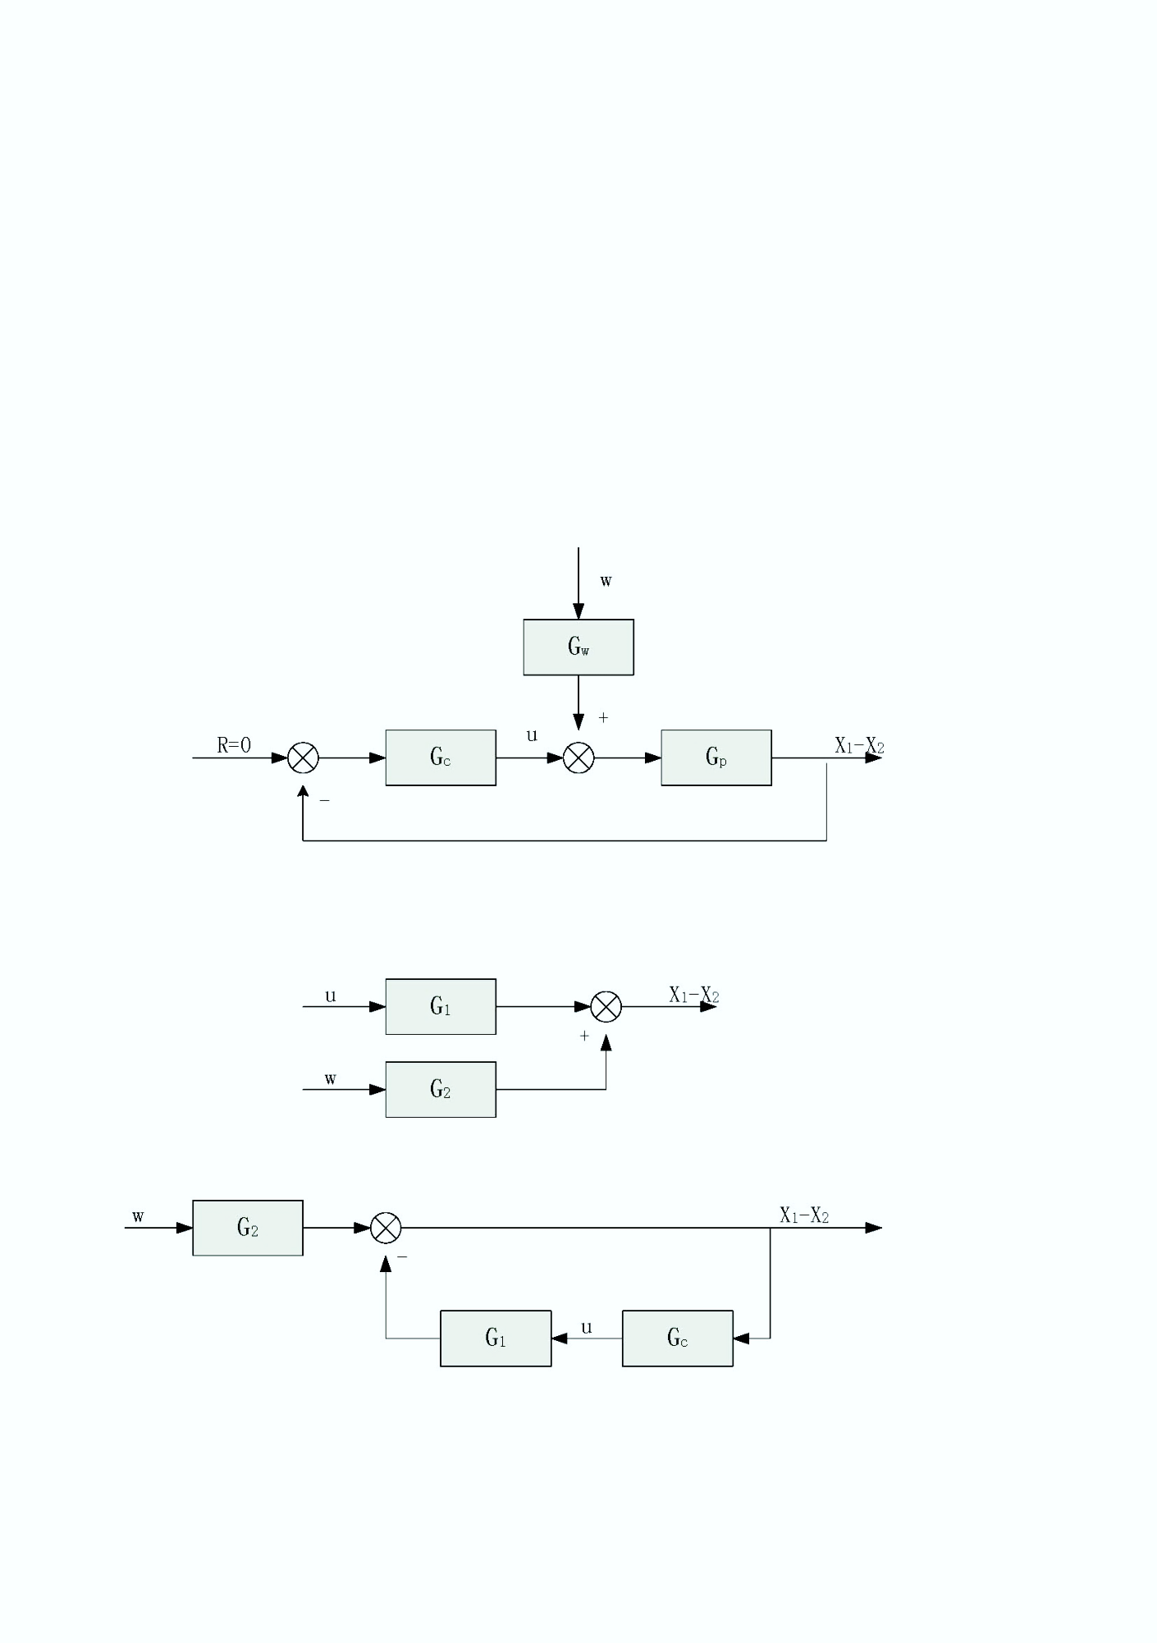

Fig.11 closed-loop system with a controller

A widely used PID control method takes 3 steps. First, select a P controller to make the system meet the overshoot requirement. Then, reduce the P in the first step and add an I element to reduce the amount of vibration before the response becomes stable. Finally, add a D element and change the P and I elements a little to get a solution.

We can write the PID-controller as following:



# 6.1 setting

Firstly we set and only set  . The response is shown below.

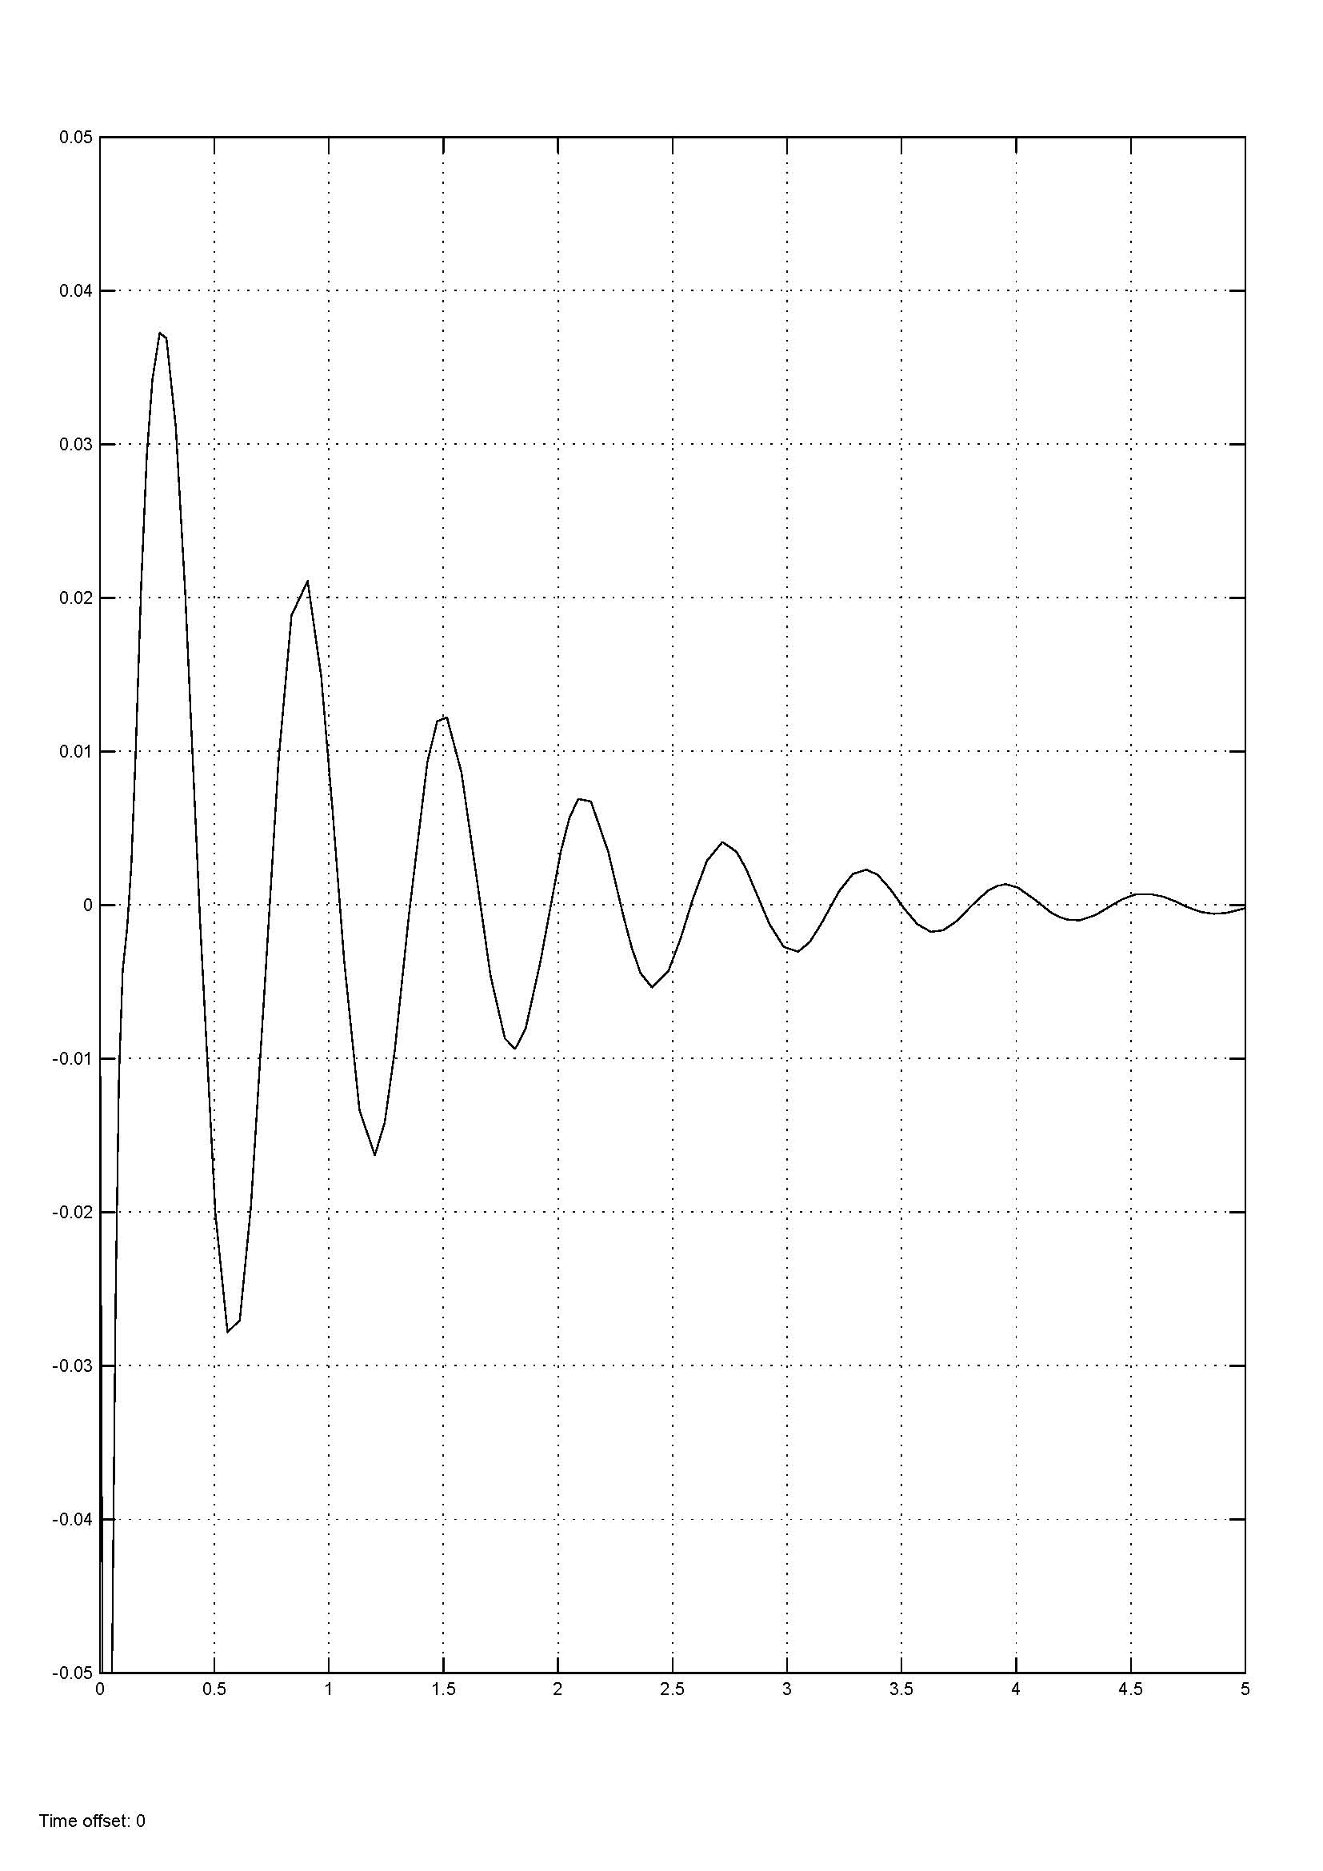

Fig.12 response to unit step disturbance ()

We can see that the response meets our overshoot requirement

# 6.2 setting

To reduce the frequency of vibration we set  and increasea little to.

Then we get the response as below:

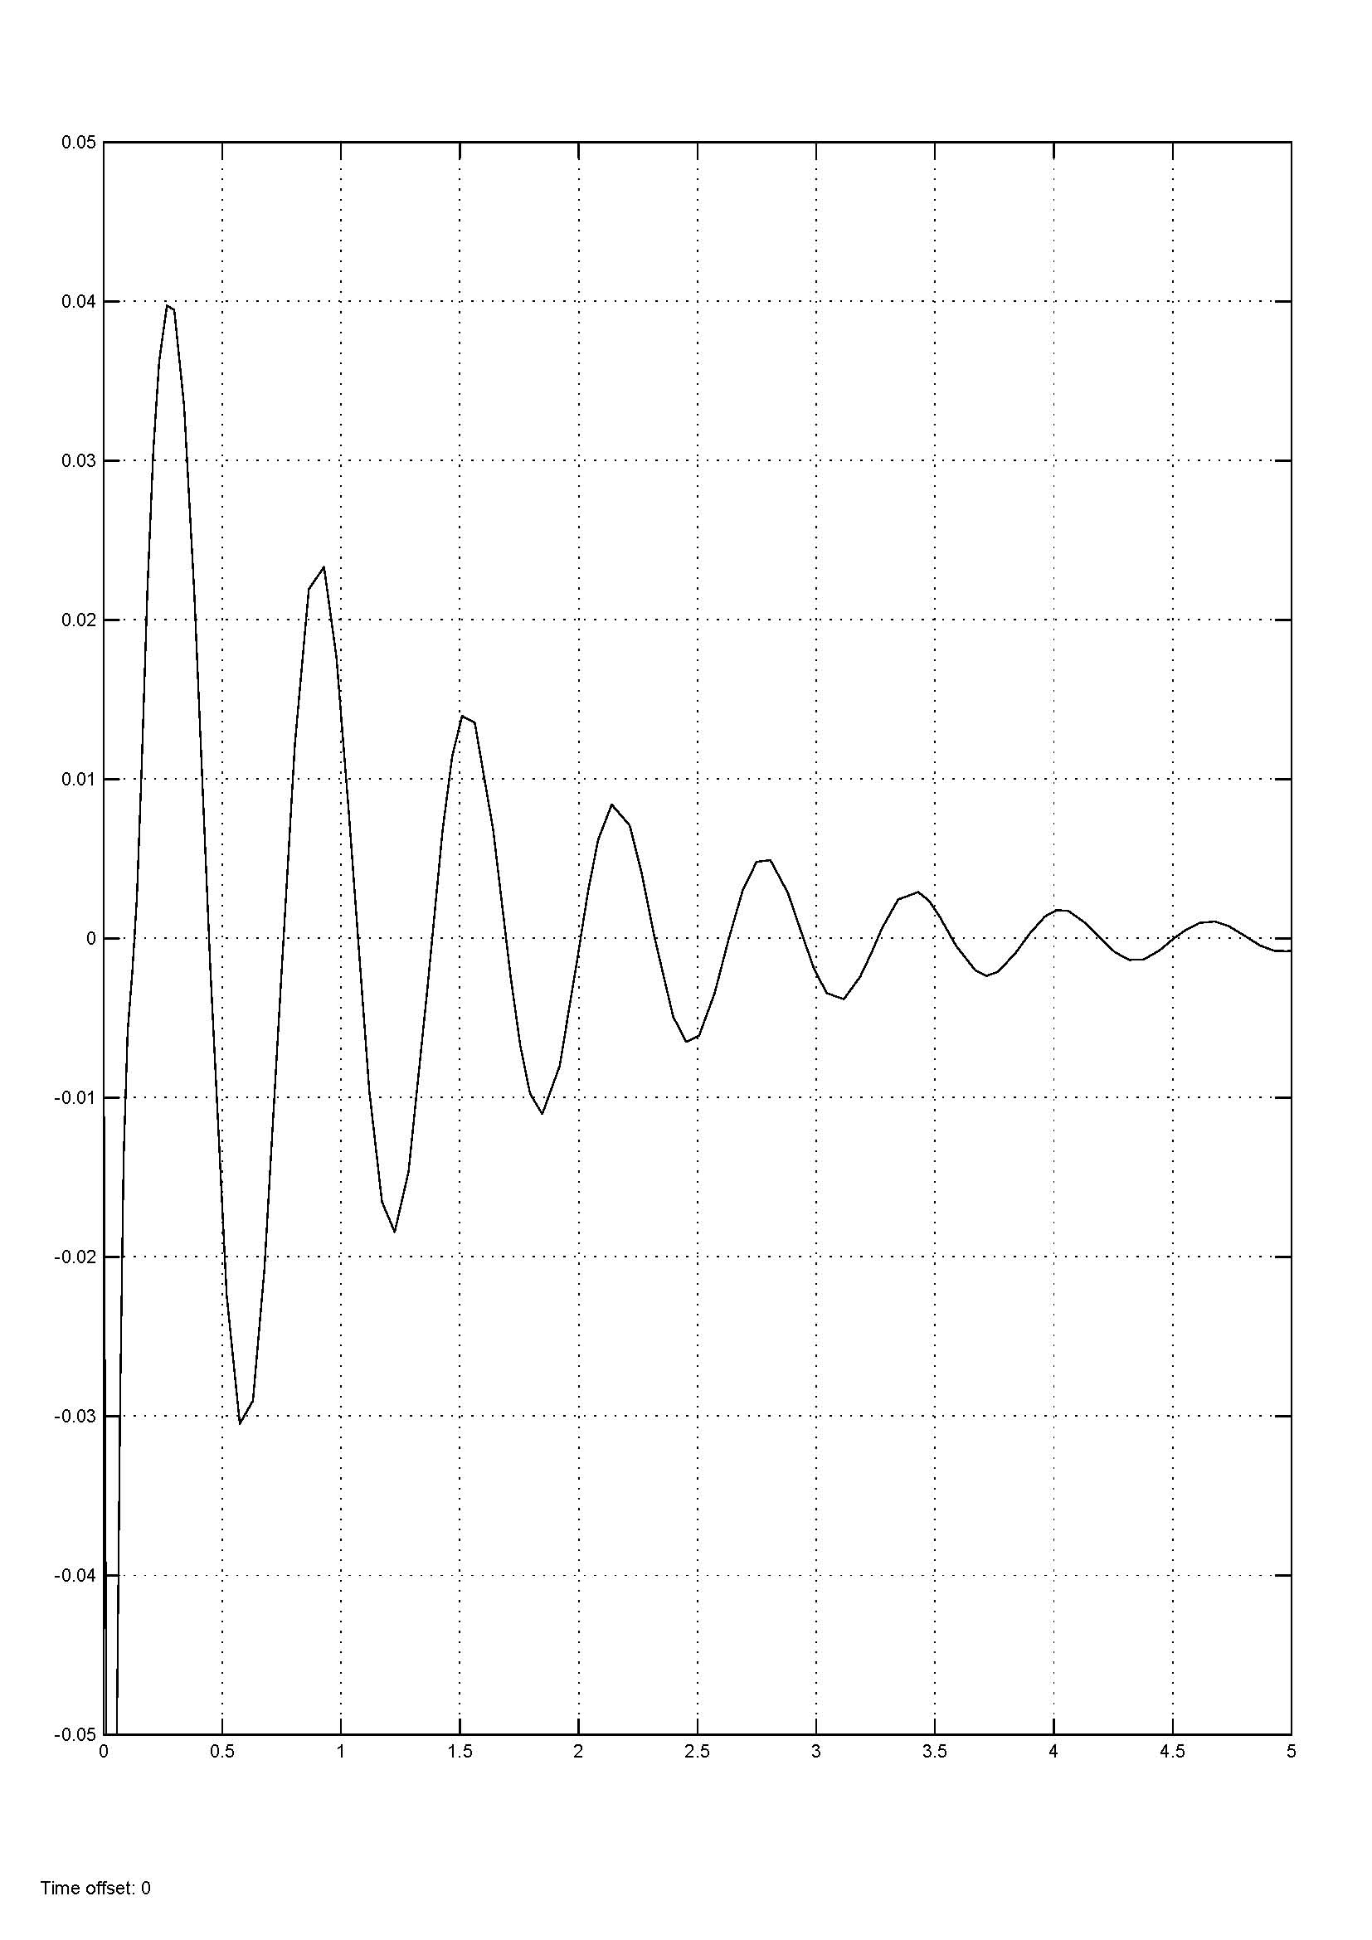Fig. 13 response to unit step disturbance ()

When I adjust the, I find that the response fast don’t variable as long as .

# 6.3 setting

We adjust to modify the overshot of the system.

After a few adjustment, we set, the response is shown as below:

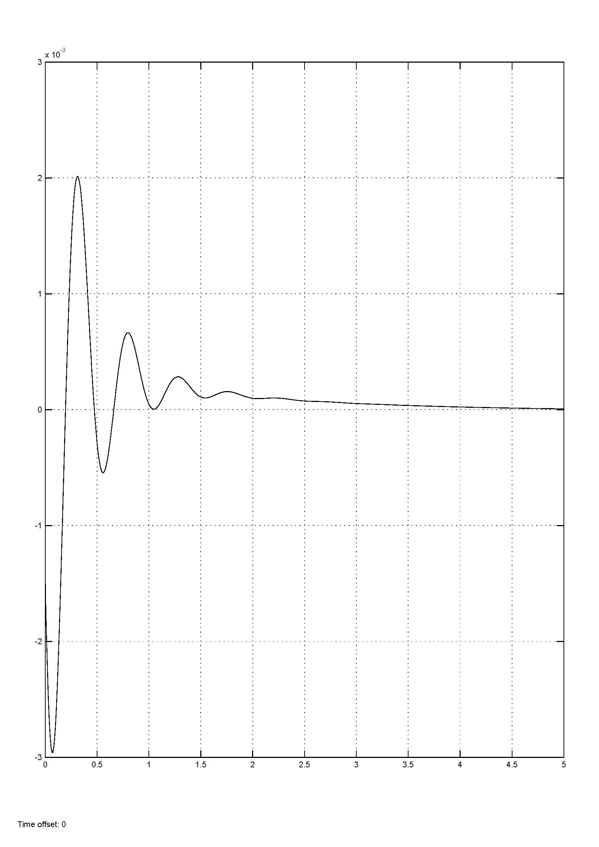

Fig. 14 response to unit step disturbance ()

The response meets all the requirements of our assignment.

The overshot of the system is about 3%.